**Memo**

To: Professor Pisano

From: Nick Gutierrez, Seok Young Choi, Yumin Lisa Wei, Eunhye Kwon

Team: 24

Date: 04/07/23

Subject: Final Prototype Test Report

1. **Required Materials**

Hardware:

* Adafruit HUZZAH32 Esp32 Feather board
* 1 LiPoly battery
* 12 Capacitive Touch Buttons
* 2 Physical Buttons
* Adafruit MPR121 12-Key Capacitive Touch Sensor Breakout
* 3D printed Controller Casing
* 8 Color Cycling LEDs
* 1 Logarithmic Slider
* 1 Power Switch
* 1 Through-hole PCB

Software:

* ESP32 code
  + Reads inputs from touch buttons and maps them to controller inputs which are then sent over Bluetooth to the computer.
* Gamepad HTML tester website
  + <https://gamepad-tester.com/>
* 1 copy of Marvel’s Spider-Man Remastered to demo in-game functionality.

**2.0 Setup**

1. Power the device by flipping the power switch.
2. Connect the device to the computer via Bluetooth
3. Press a couple of buttons to verify inputs are being registered.
4. Open the Gamepad Tester site and verify the controller is being picked up.

**3.0 Testing Procedure**

1. Demonstrate how the user’s hands should be placed and joystick mobility.
2. Demonstrate LED brightness adjustments using the slider
3. Open the Gamepad testing site and demo each button/joystick corresponding to the correct gamepad output.
4. Show control mapping in Steam’s Big Picture Mode
5. Open Spider-Man and show the controller inputs completing the corresponding action in-game
6. Swing around in Spider-Man and demonstrate movement and combat

**4.0 Measurable Criteria**

* Minimal mobility issues when using the palm joysticks and pressing the touch buttons.
* LED brightness is adjusted with the slider
* Gamepad testing site shows the correct output for controller inputs.
  + Both buttons and joysticks
* Spider-Man is demonstrated and completed.

**5.0 Esp Input to Controller Button Mapping**

| **Arduino Button** | **Controller Button** |
| --- | --- |
| Physical Button 1 (BUTTON_0) | Start |
| Physical Button 2 (BUTTON_1) | Select |
| BUTTON_2 | Left Joystick Push In |
| BUTTON_3 | Right Joystick Push In |
| BUTTON_4 | X |
| BUTTON_5 | Y |
| BUTTON_6 | LT |
| BUTTON_7 | LB |
| BUTTON_8 | RB |
| BUTTON_9 | RT |
| BUTTON_10 | A |
| BUTTON_11 | B |
| BUTTON_12 | DPad Up |
| BUTTON_13 | DPad Down |
| BUTTON_14 | DPad Left |
| BUTTON_15 | DPad Right |

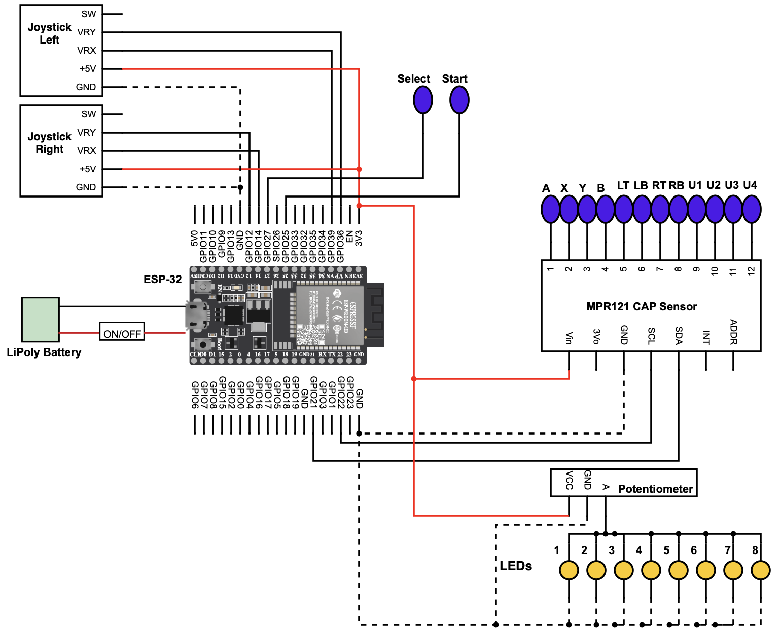

**Figure 1**: Schematic of the controller. This controller has an Adafruit HUZZAH32 Esp32 Feather, 12 touch buttons, two physical buttons, a slider, and two joysticks.

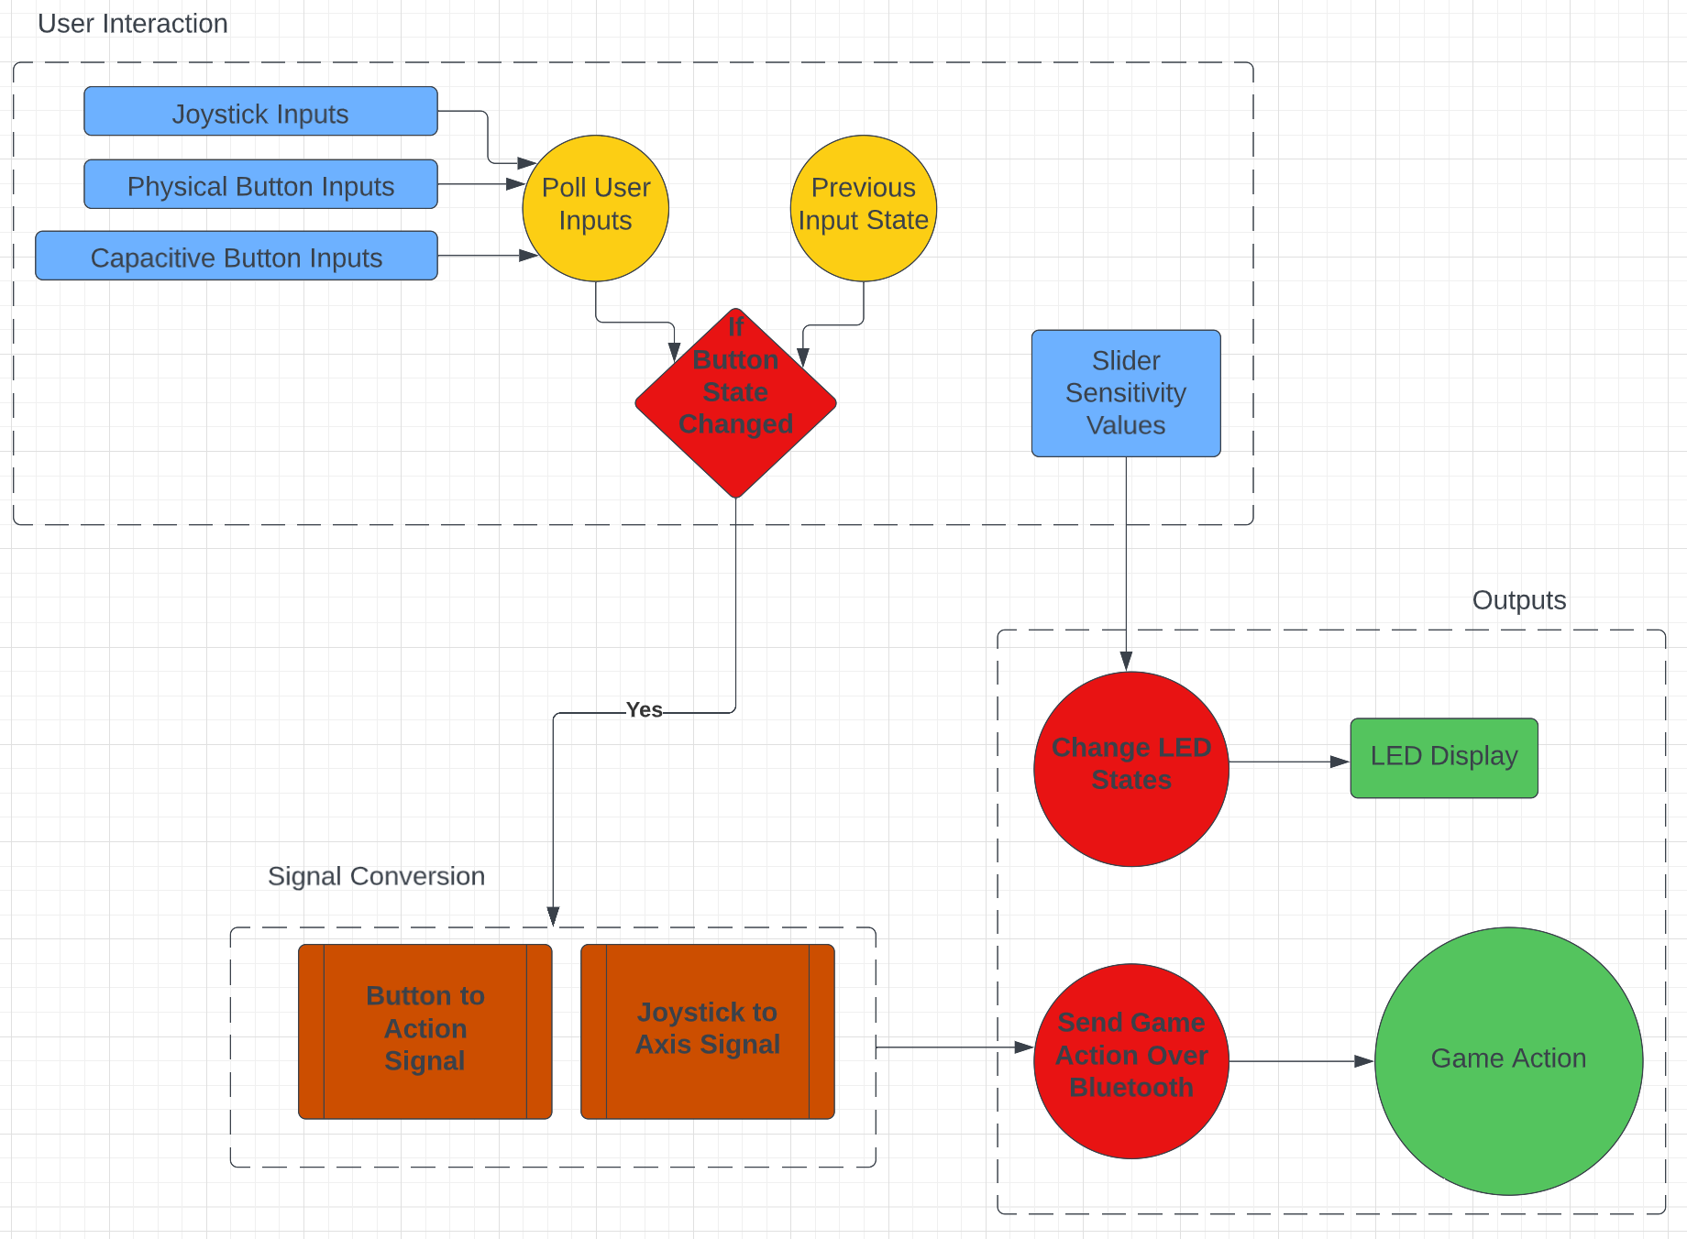

**Figure 2:** Software Flow Diagram of Controller. User Inputs are polled in a loop, converted to the proper signals, and sent to the game

**6.0 Score Sheet**

**6.1 Controller Hardware/Software Testing**

**Table 1**: Controller buttons testing results. The functionality of the buttons will be tested through gaming controller outputs, and game action performances.

| Button | Correct Controller Output? | Game Action Performed? | Button Hard to Press While Playing? | Total Score |
| --- | --- | --- | --- | --- |
| BUTTON_0 | YES | YES | NO | 100% |
| BUTTON_1 | YES | YES | NO | 100% |
| BUTTON_2 | YES | YES | NO | 100% |
| BUTTON_3 | YES | YES | NO | 100% |
| BUTTON_4 | YES | YES | NO | 100% |
| BUTTON_5 | YES | YES | NO | 100% |
| BUTTON_6 | YES | YES | NO | 100% |
| BUTTON_7 | YES | YES | NO | 100% |
| BUTTON_8 | YES | YES | NO | 100% |
| BUTTON_9 | YES | YES | NO | 100% |
| BUTTON_10 | YES | YES | NO | 100% |
| BUTTON_11 | YES | YES | NO | 100% |
| BUTTON_12 | YES | YES | NO | 100% |
| BUTTON_13 | YES | YES | NO | 100% |
| BUTTON_14 | YES | YES | NO | 100% |
| BUTTON_15 | YES | YES | NO | 100% |

**Table 2:** Joystick Testing. The functionality of the joysticks will be tested through gaming controller outputs, game action performances, and ease of use.

| Joystick | Comfortable Rest Position? | Easy to Move Around in Game? | Can Be Operated in Tandem with Other Joystick? | Total Score |
| --- | --- | --- | --- | --- |
| Left | YES | YES | YES | 100% |
| Right | YES | YES | YES | 100% |

**Table 3:** Other Hardware. The other pieces of Hardware need to be tested for their individual functionality (defined in the table below) and that they don’t interfere with normal gameplay (blocks buttons, sends mixed signals, etc.).

| Hardware | Functioning Properly? | Nonobstructive to Gameplay? | Total Score |
| --- | --- | --- | --- |
| Power Switch+Battery  (Powers device independent of charging cord) | YES | YES | 100% |
| LEDs  (Light up when the device is powered and cycles through colors) | YES | YES | 100% |
| Slider  (Adjusts LED Brightness) | YES | YES | 100% |

**7.0 Conclusion**

The final prototype of our inclusive video game controller for individuals with hand arthritis has successfully undergone testing for functionality, ease of use, and comfort. Based on feedback from the Boston Medical Center focus group study during our second prototype test, we have made the necessary changes to the prototype and achieved outstanding results.

The controller buttons, joystick, and other hardware components have each received perfect scores for their respective tests. Our team is proud of the progress in developing a product that prioritizes inclusivity and accessibility for individuals with hand arthritis.

Looking towards the future, our team has several planned steps to further improve the functionality and user experience of our inclusive video game controller. Firstly, we will conduct tests on battery life to determine if the lithium-ion polymer battery we have selected can provide 24 hours of continuous gameplay. Additionally, we will perform tests on input lag to ensure that the controller's software can deliver smooth gameplay.

Our team is also looking into incorporating customizable features into the controller design.

Right now, we have interchangeable joystick sizes to allow users to choose the most comfortable joystick size for their hands. We would like to create a more simplified version that is easier for the customer to use.

Moreover, we will make design changes to the controller to enhance its aesthetics and usability. These changes include adding a logo on the side of the controller and incorporating non-slip rubber to the base of the controller to prevent slipping during gameplay.

We are grateful to the Boston Medical Center focus group for providing valuable feedback that enabled us to refine our product to be suitable for individuals with hand arthritis. We are committed to improving our inclusive video game controller to meet the needs and preferences of individuals with hand arthritis. By April 17th, we plan to have a User's Manual available to help users understand and operate our product effectively. Our team is dedicated to creating a product that not only enhances the gaming experience for individuals with hand arthritis but also promotes inclusivity and accessibility in the gaming industry.